Power BI Assignment 2 – DAX & Data Visualization

By Fathima Resmin (69)
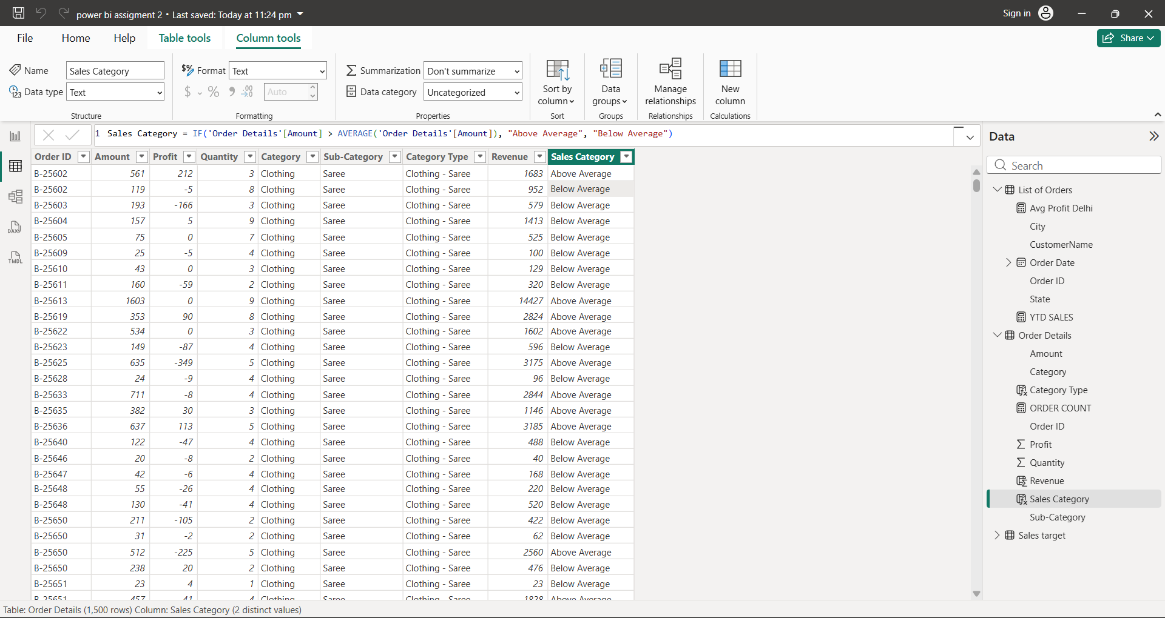
- Import these three data into power bi
★ List of Orders.csv
★ Order Details.csv
★ Sales target.csv
Calculated Columns;
● Create a Calculated Column for 'Category Type': Add a calculated column in the
Order Details table that combines the 'Category' and 'Sub-Category' columns into
single 'Category Type' column.

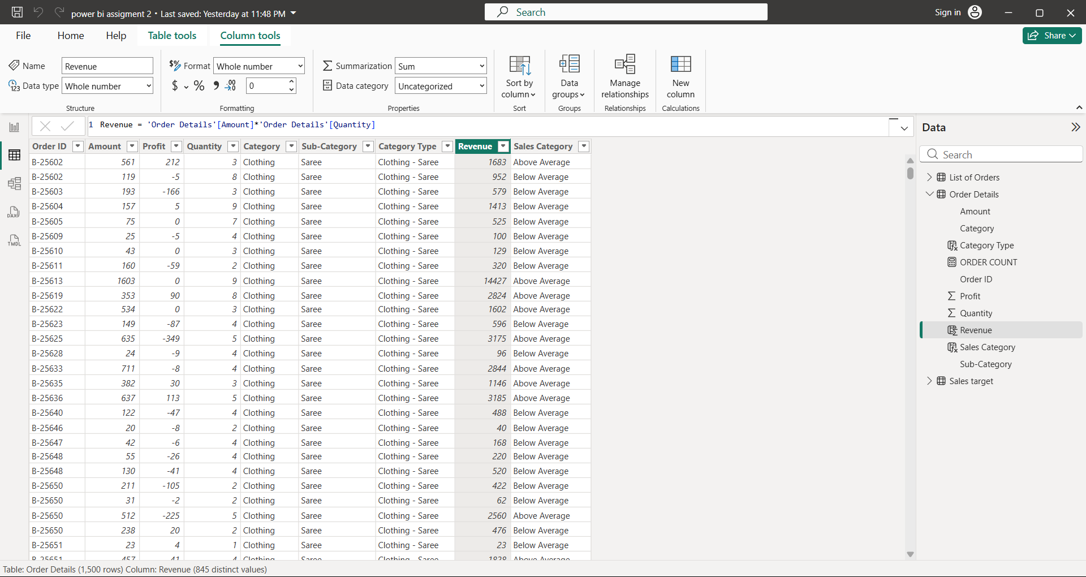
● Calculate Revenue per Order in Order Details Table: Create a calculated column in
the Order Details table to compute the revenue (Amount * Quantity) per order.
● Create a Calculated Column to Categorize Sales: Add a calculated column named
‘Sales Category’ in the Order Details table that categorizes each order as 'Above
Average' or 'Below Average' based on the Amount value
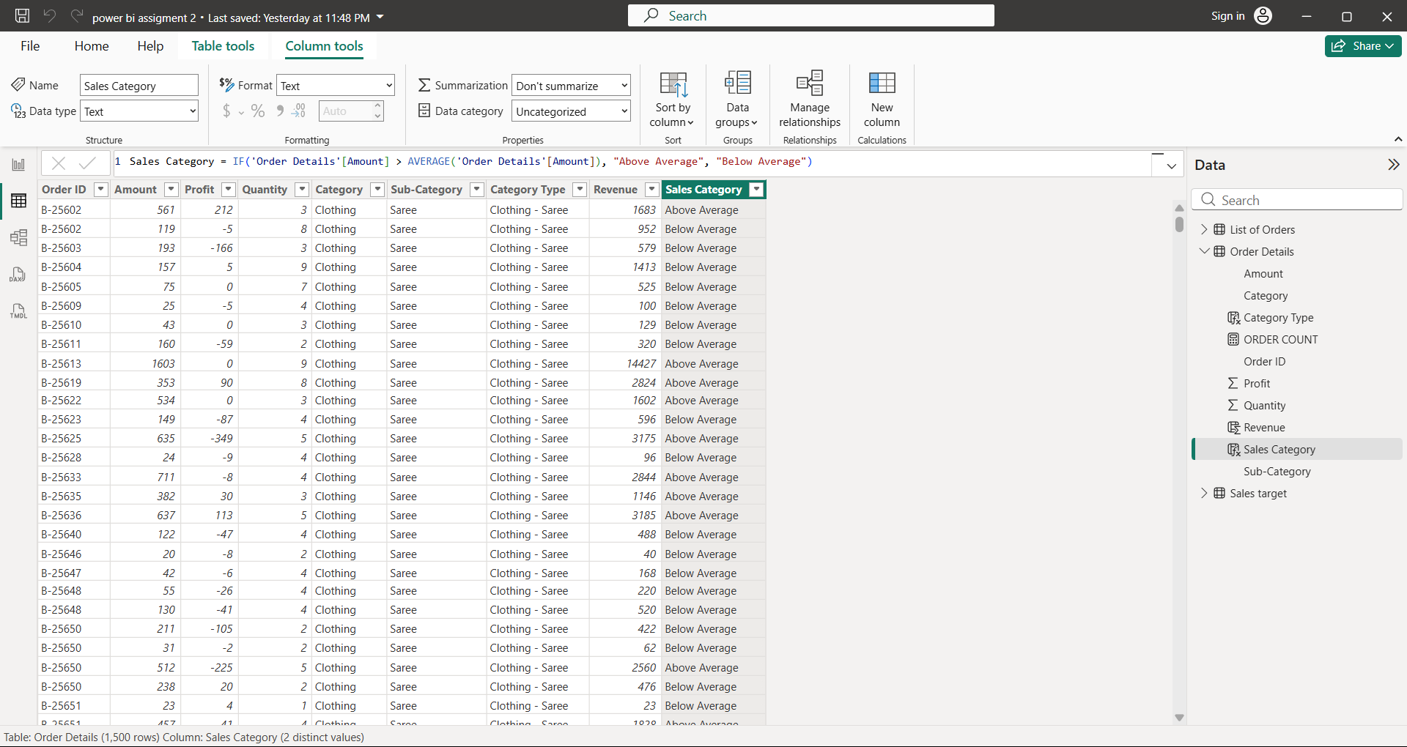
Calculated Measures:
● Calculate Order Count: Define a measure to count the total number of orders in the
Order Details table.
● Calculate Average Profit in Delhi: Create a measure to calculate the average profit for
orders placed in Delhi.
● Calculate Year-to-Date (YTD) Sales: Define a measure to calculate the total sales
amount accumulated from the earliest order date up to each order date.

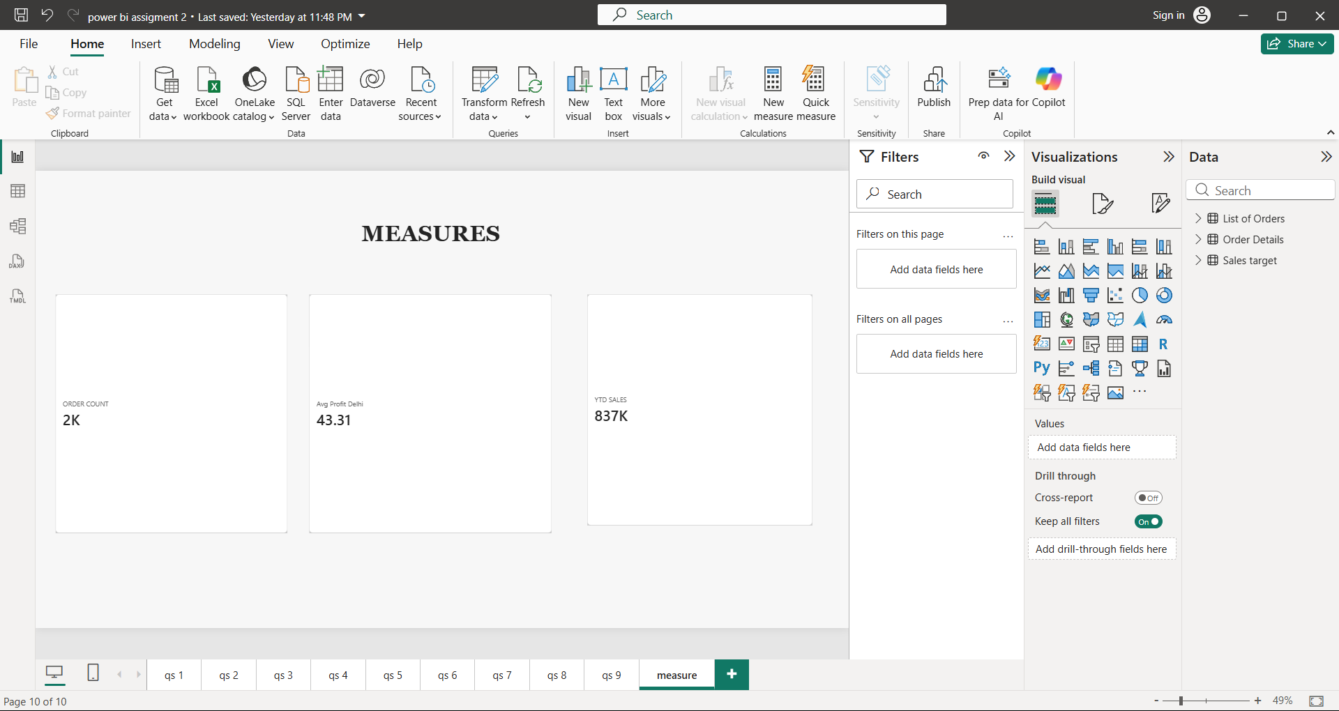
Data Visualization:
? Sales Target Achievement by Category: Compare actual sales with sales targets by
category using a clustered column chart.
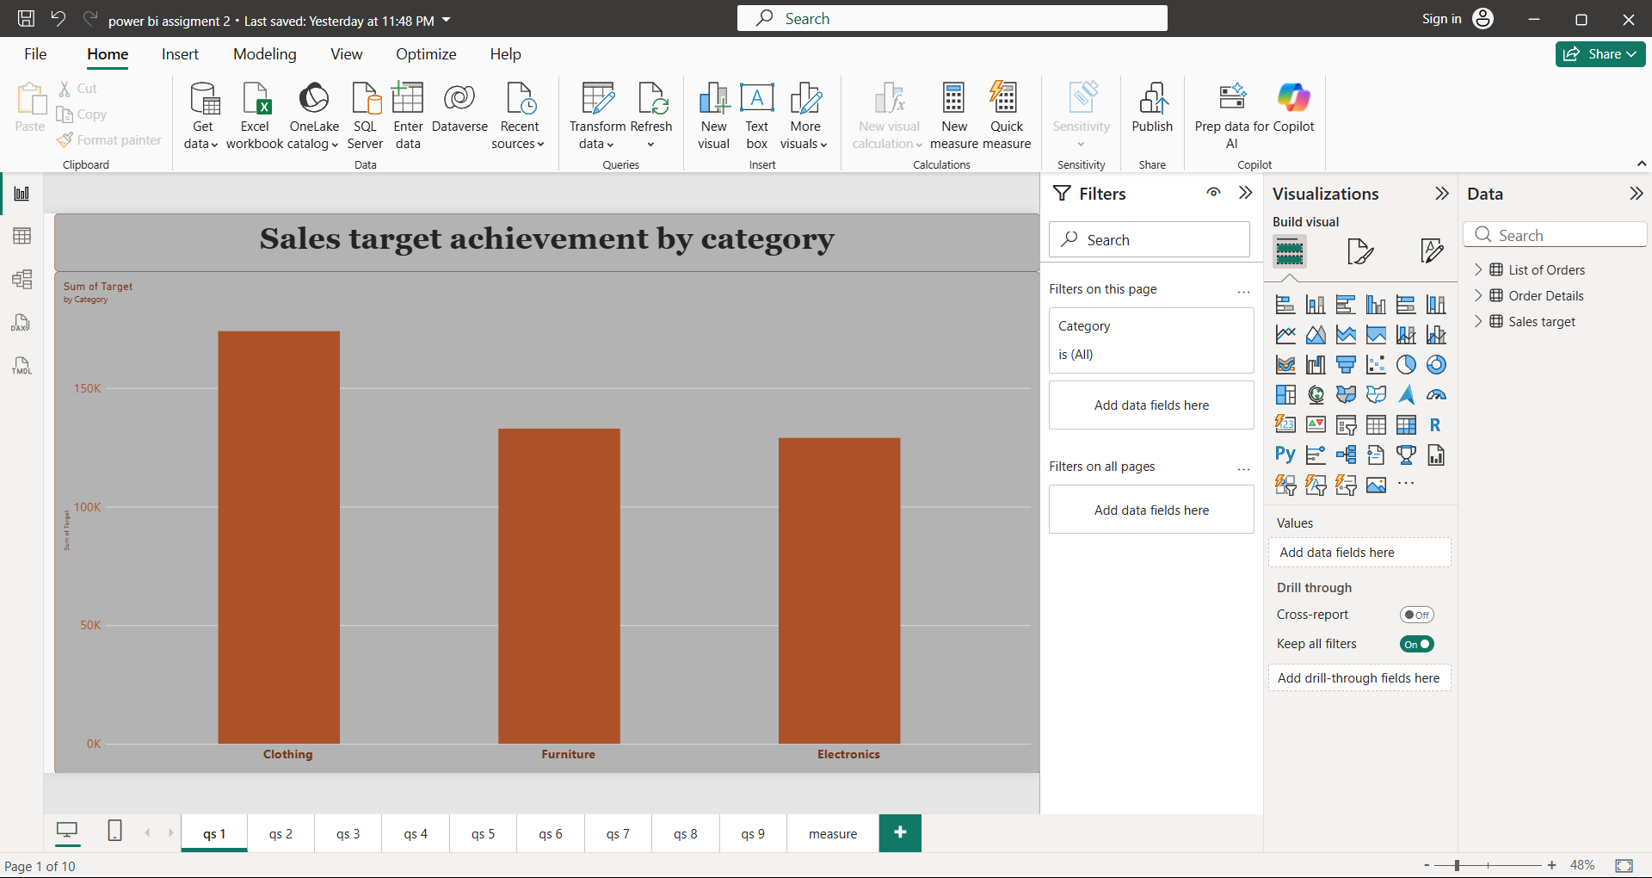
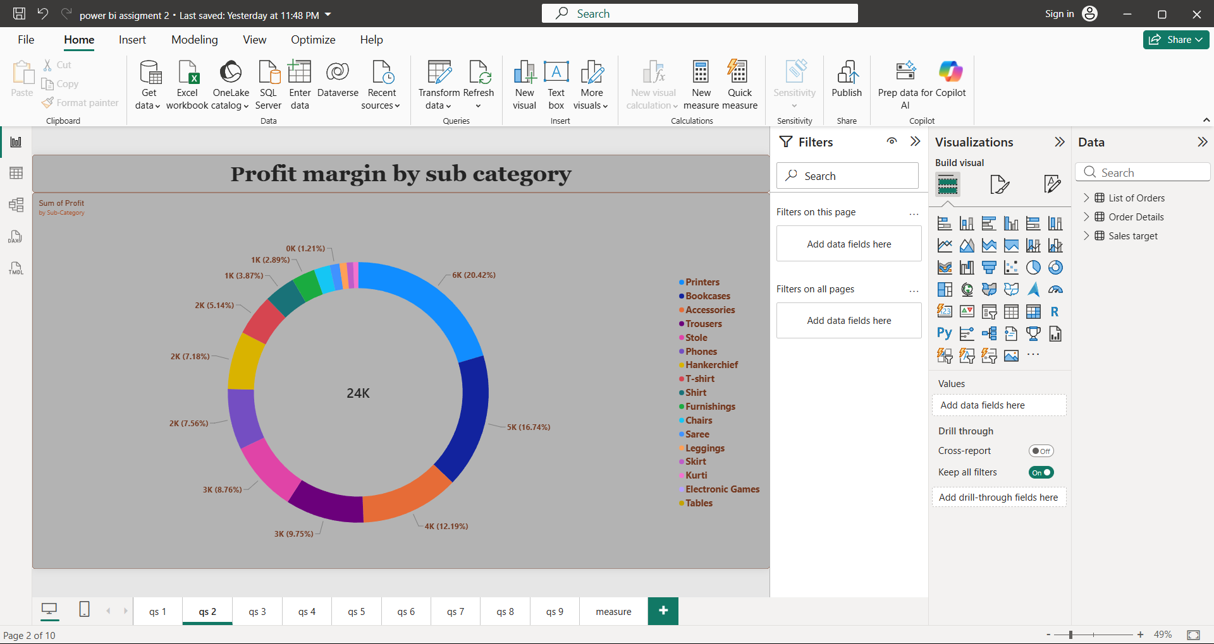
? Max Profit Margin by Sub-Category: Analiese the maximum profit margin for each
sub-category of products using a donut chart.
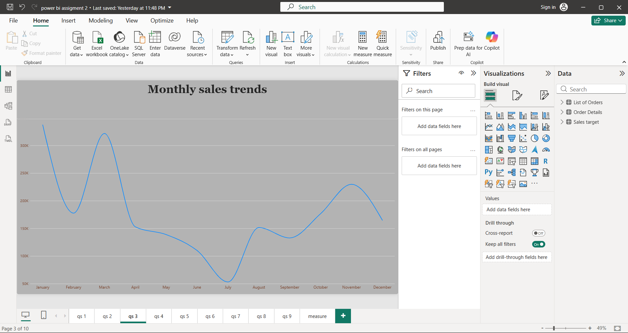
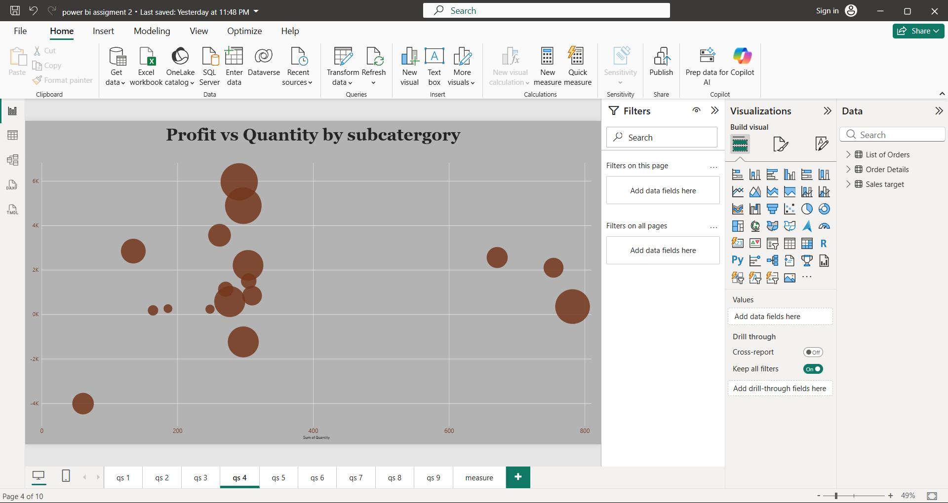
? Monthly Sales Trend: Show the trend of monthly sales over time using a line chart.
? Comparison of Profit and Quantity by Sub-Category: Compare the relationship between
profit and quantity sold for different sub-categories using a scatter chart.
? Comparison of Total Sales Amount and Target: Create cards to succinctly display the total
sales amount alongside the sales target for quick comparison and analysis. Also, create a
multi-row card to display the minimum target for each segment.
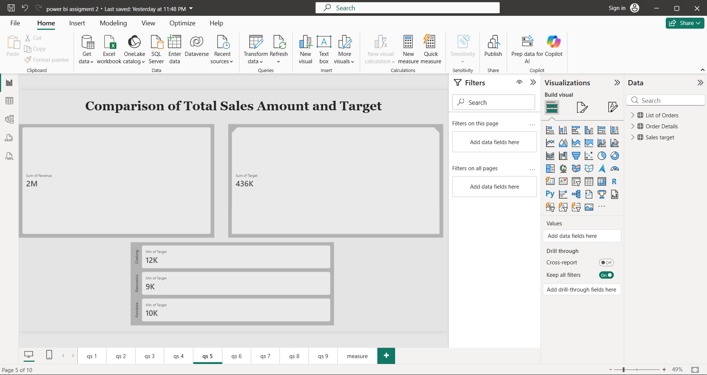
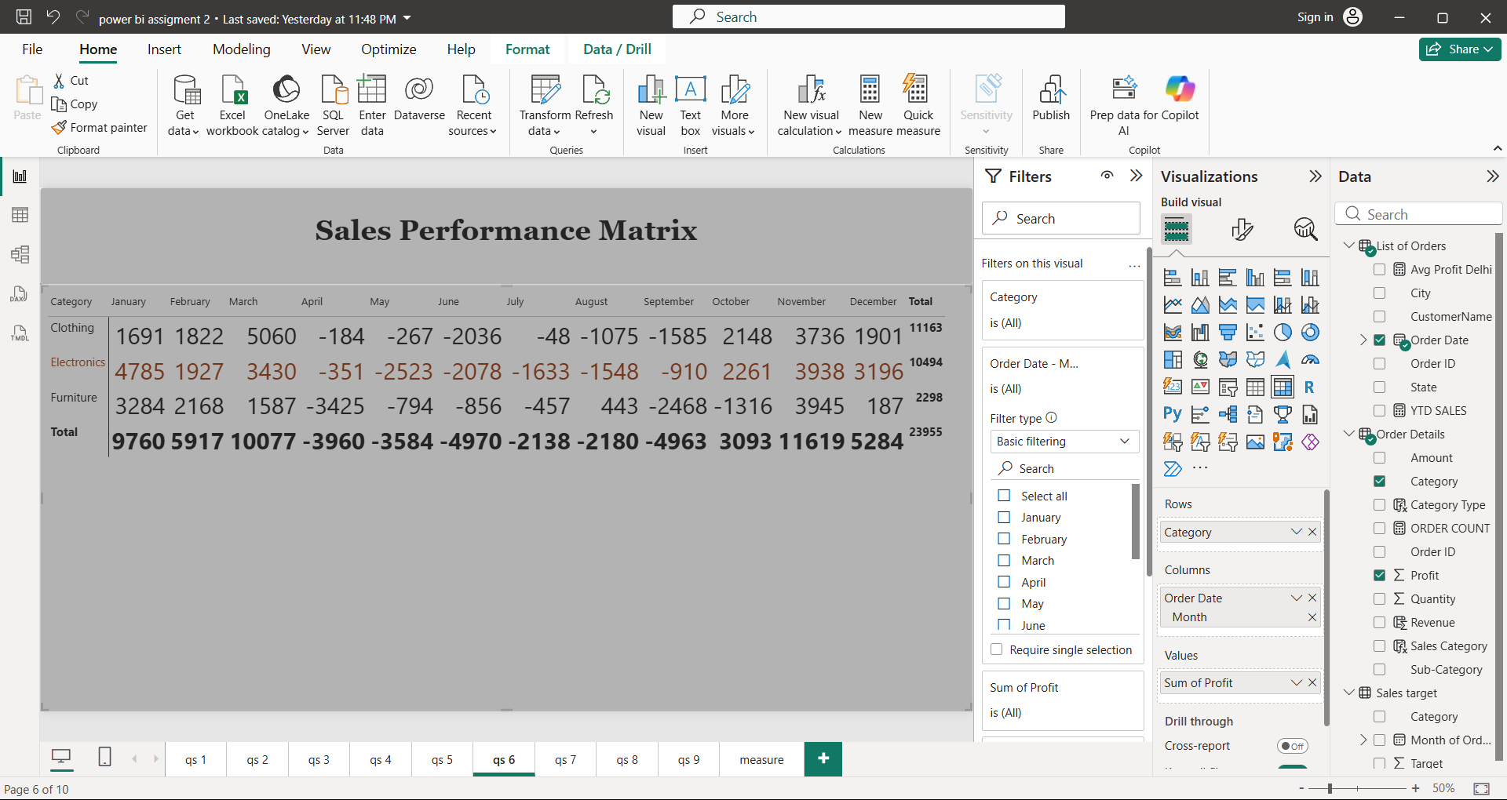
? Sales Performance Matrix: Build a matrix view to analyse how actual sales compare to
sales targets across different categories and months.
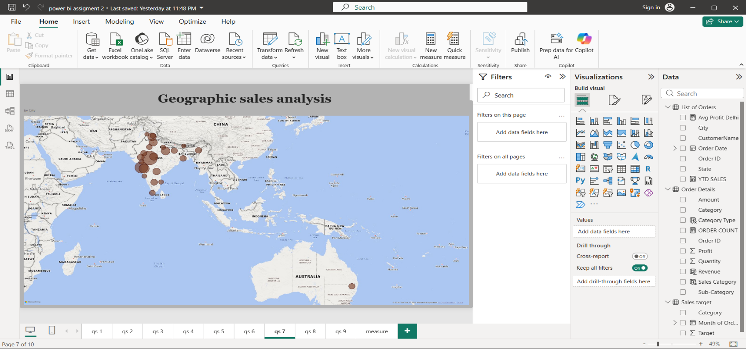
? Geographic Sales Analysis: Visualize total sales on a map by city to identify regional sales
patterns.
? Sales Distribution by Sub-Category: Represent the sales distribution across different
sub-categories using a tree map.

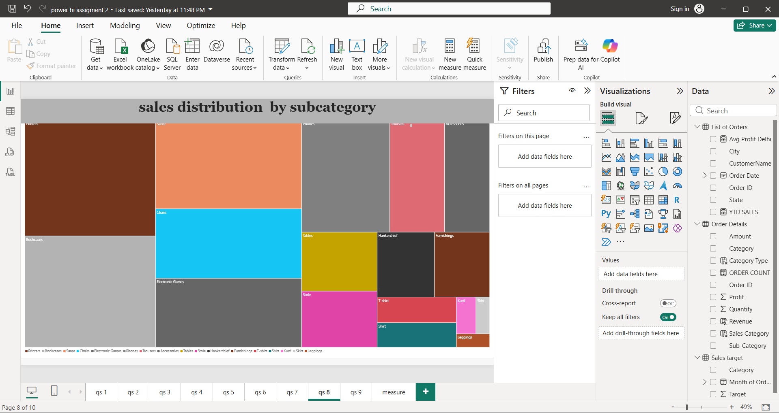
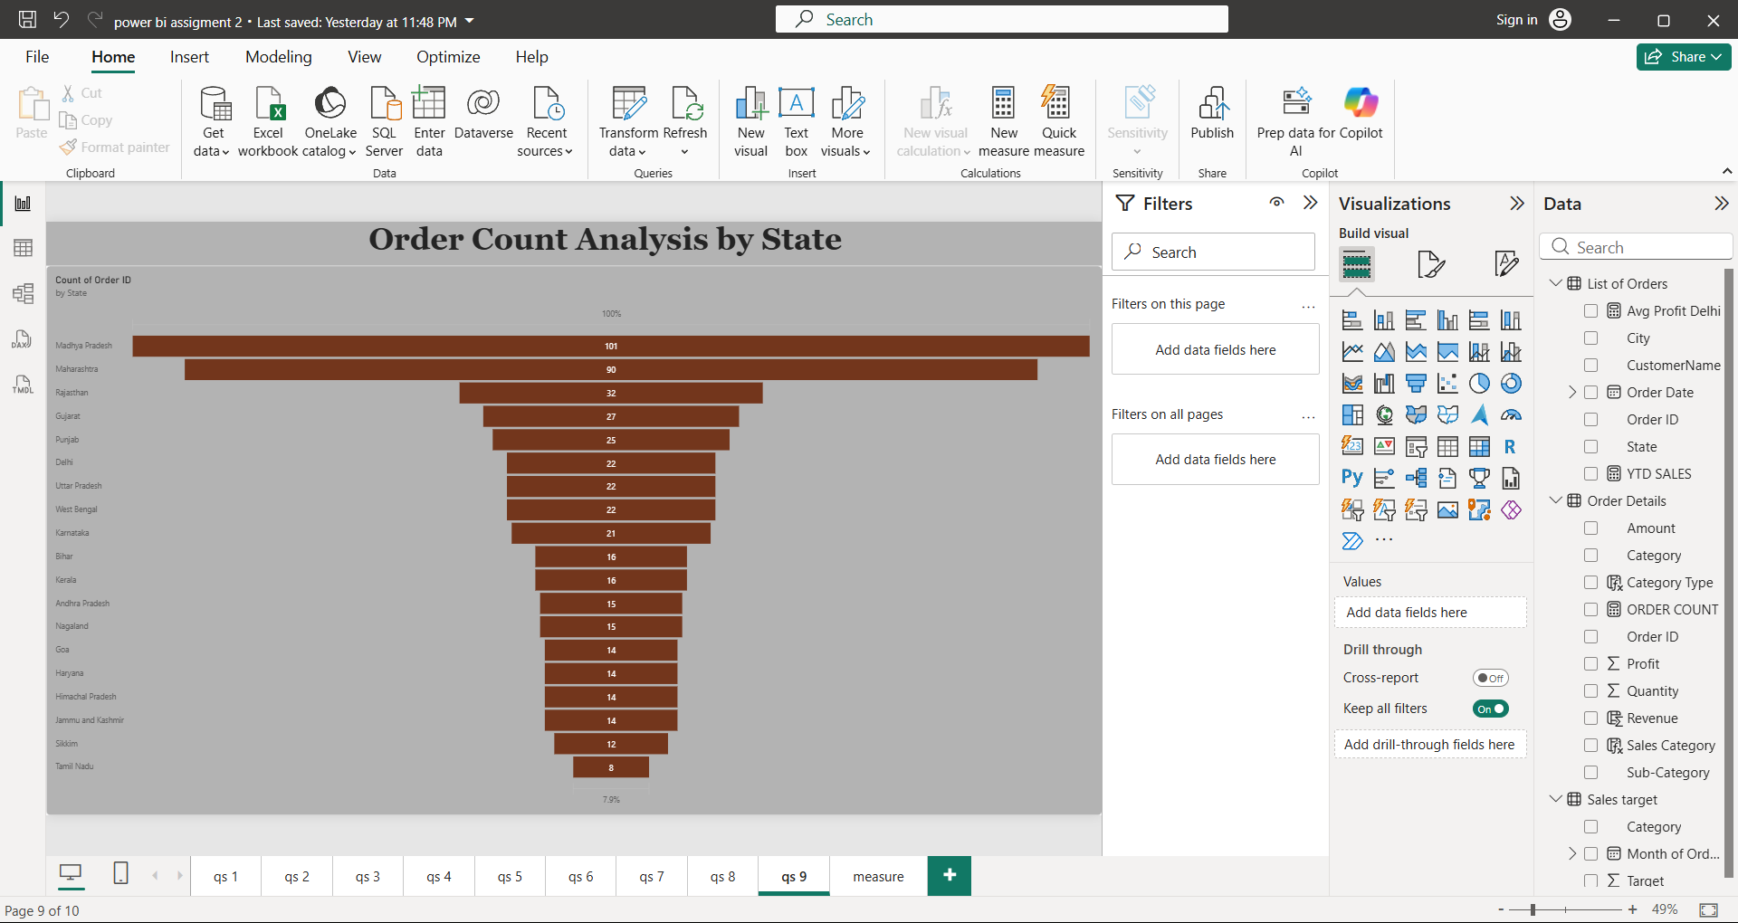
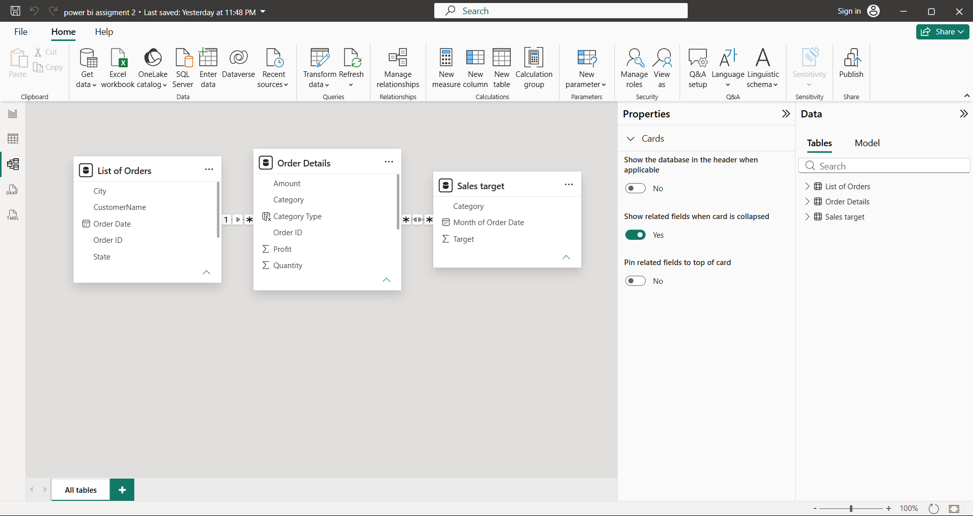
? Order Count Analysis by State: Create a funnel chart to visualize the distribution of order
counts across different states.
Relationship

